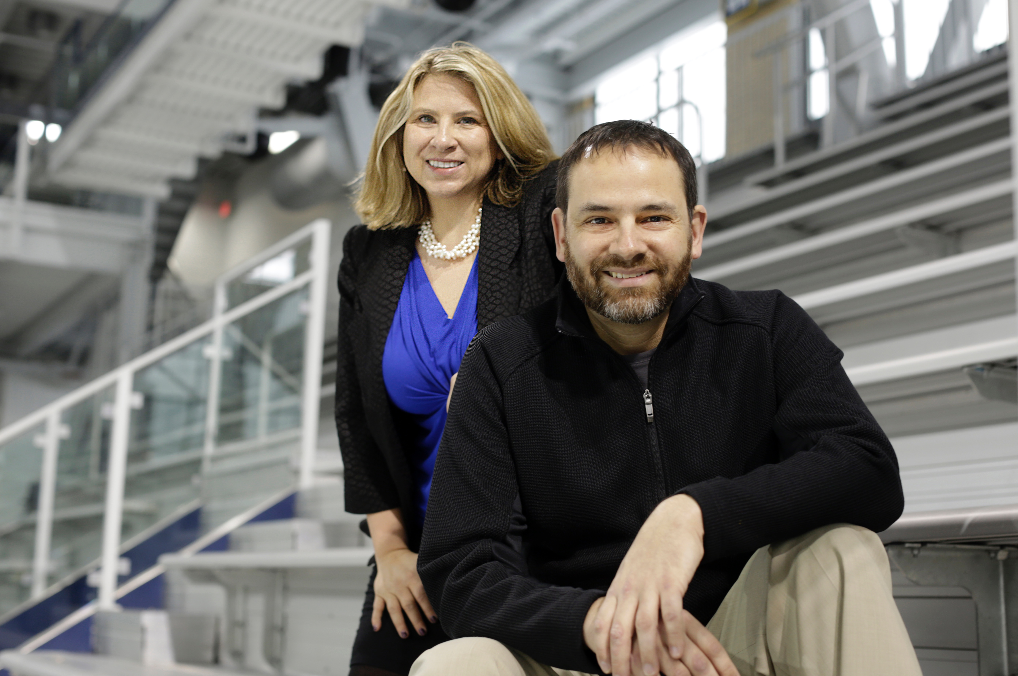

# Coming October 2016, from Oxford University Publishing

## **Expert sports neurologist Dr. Jeff Kutcher (executive director, The Sports Neurology Clinic) and award-winning sports journalist Joanne C. Gerstner (N.Y. Times/ESPN/Detroit News) are tackling today’s top concern for youth sports parents, coaches and athletes: the risk of sports concussion. “Concussion” is a science-driven book, looking at the youth concussion issue, and delving into what needs to be discussed – on and off the field. Former Olympians, professional and college stars, and today’s youth parents, coaches and athletes talk about their experiences, combining with Kutcher and Gerstner’s deep expertise for a real-world discussion. The goal is to educate and empower the three out of four American families with children playing organized sports.**

## **Kutcher and Gerstner are sought-after experts on sports concussions, the pop culture/media hype around the sports injury, and what it all means to the world of sports. They have been featured presenters at South by Southwest 2015, and also have appeared on WDET, NPR, NBC, the BBC, ESPN and other outlets.**

**ISBN: 9780190226602**

## 

**Back in the Game**

**Why Concussion Does Not Have to End Your Athletic Career**

For more information:

Twitter: @joannecgerstner @jeffkutcherMD

To book Joanne C. Gerstner/Dr. Jeff Kutcher for appearances: joanne@joannecgerstner.com